## PROJECT NAME: Unearthing The Environmental Impact of Human Activity: A Global CO2 Emission Analysis



**Category: Data Analytics**

**Skills Required:**  
Exploratory Data Analysis, MySQL, Databases, Tableau

**Team leader : M Satyavani**

**Team members : 1) M Durga Narasimha Naidu**

**2) M Lokesh**

**3) Rakesh**

**4) Venkata Ramana**

**Project Description:**

#### Global warming is one of the biggest challenges currently being faced by the human race, although the correlation is not causation a likely cause of global warming is increased atmospheric carbon dioxide from human activities. CO2 Emission refers to the Carbon Dioxide emitted throughout the world. For this analysis, we will be focusing on CO2 Emissions and their effect on the world we live in as well as some key factors and stats that may play a role in the emission of CO2 globally. Fossil fuel use is the primary source of CO2. The data throws light onto how much fossil fuels are burnt, per year per nation, which amounts to an increase in CO2 every year. This will help researchers and environmental experts to predict global warming. So that countries should set a goal to decrease this amount yearly.

Analyzing Global Co2 Emission across countries from 1975 to 2020. This dataset contains a record of Co2 Emission by each Country and Region of Earth, here we are going to analyze and visualize Country-wise, Region wise and Overall Co2 Emission on Earth.

**Technical Architecture:**

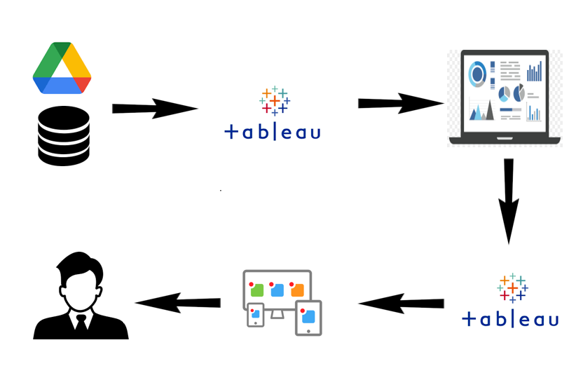

**Pre-Requisites**

For Completing this project these are some of the prerequisites needed

* A system with a minimum 4GB RAM and 128GB Hard Disk
* Good Internet Connection
* Google Drive / Any of the Database Server with Management Studio
* MySQL:
* **SQL Server Management Studio:**
* **Tableau Desktop:**
* Tableau Public Account: <https://public.tableau.com/app/discover>
* Html, CSS or Bootstrap

### **Prior-Knowledge**

To Complete this project, one must understand the below concepts and able to work with the tools

* **Data Visualization:**
* **Univariate, Bi- Variate and Multi-Variate Analysis**
* **Chart Types:**
* **Tableau:**
* **Business Intelligence:**

### **Project Objectives**

By the end of this project, you will:

* Able to Connect Tableau with different data sources
* Know fundamental concepts and techniques used for Data Visualization.
* Gain a broad understanding about data and different types of charts.
* Have knowledge of developing Visualizations, Dashboards and Story.
* Able to Integrate the developed dashboard and story with the web application

### **Project Flow**

To accomplish this, we have to complete all the activities listed below,

* Data collection
  + Collect the dataset or create the dataset
* Database /Spreadsheet Connection
  + Understand the dataset
  + Import Dataset into the database
  + Connect Tableau Desktop to Database server.
* Visualizing and analyzing data
* Understand the Data and the Business Questions
* Based on the Business questions develop the different visualizations
* Dashboard
  + Develop the Dashboard
* Story
  + Develop the Storyboard
* Publishing to the Tableau Public & Web Application Integration
  + Developed Visualizations, Dashboard and story will be published to Tableau Public Account.
  + Once it is published, we will get the shareable links
  + Develop a web application using HTML, CSS or Using Bootstrap
  + Integrate the Visualizations, Dashboard and Story with the Web Application

# Data Collection

Data collection is the process of gathering and measuring information on variables of interest, in an established systematic fashion that enables one to answer stated research questions, test hypotheses, and evaluate outcomes and generate insights from the data.

LINK:

<https://drive.google.com/file/d/1n764uDPT_ZF7kzGFLtpxkwBBsDBScbWm/view>

## Working With Dataset

### **Understand The Data**

The dataset consists of CO2 emissions in metric tons per capita of every country around the world. The data is collected from 1975 to 2020. In this dataset Countries and regions are included. Data is initially pre-processed using excel.

The dataset contains Country-

* Country for which Co2 is Recorded
* Year- Year the data was recorded
* Co2 Emission (In Million Metric Tons)
* Co2 Growth per Capita
* Co2 Per Capita
* Cumulative Co2
* Several Fossil Fuels rate of Emission

# Data Visualization

Data visualization is the process of creating graphical representations of data in order to help people understand and explore information. The goal of data visualization is to make complex data sets more accessible, intuitive, and easier to interpret. By using visual elements such as charts, graphs, and maps, data visualizations can help people quickly identify patterns, trends, and outliers in the data.

### **😊 Total World Emission,**

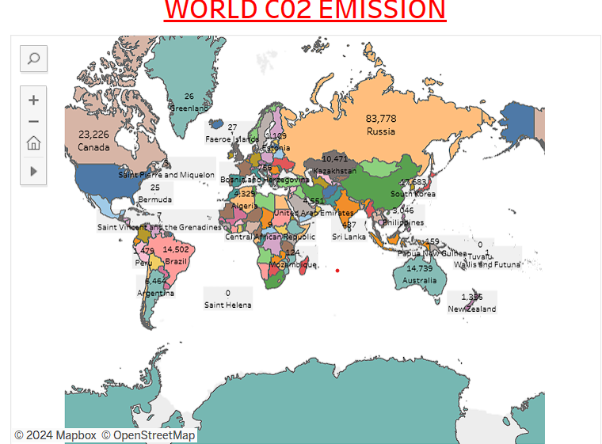

**😊 Co2 Emission Over Time**

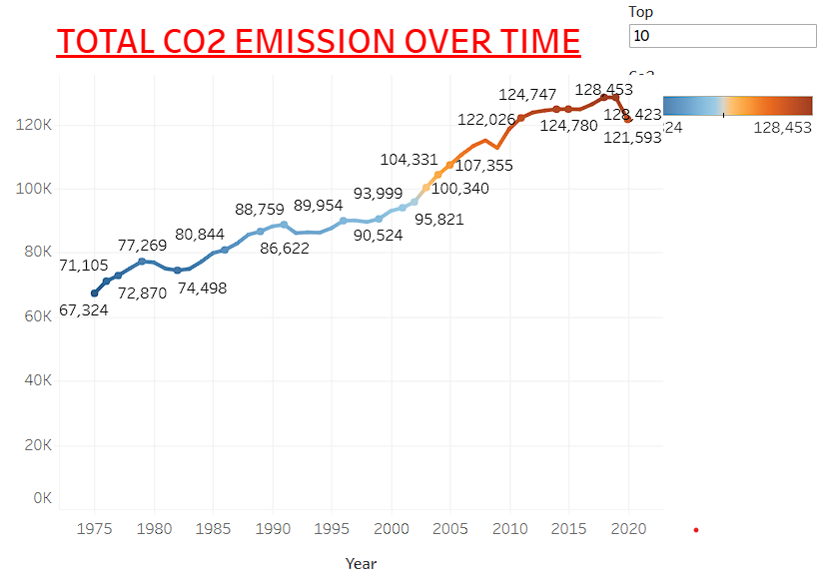

**😊 Total Emission by Continents**

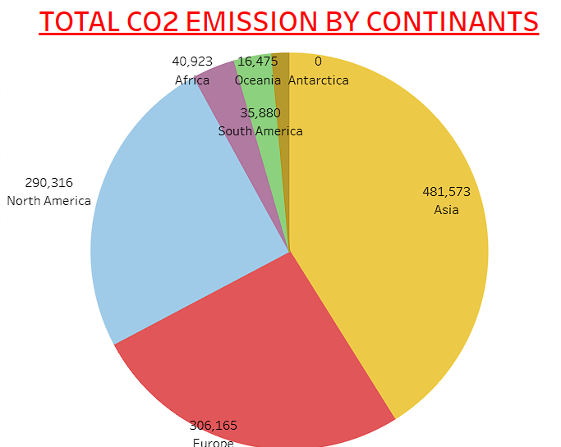

### **😊 Co2 Emission Per Capita**

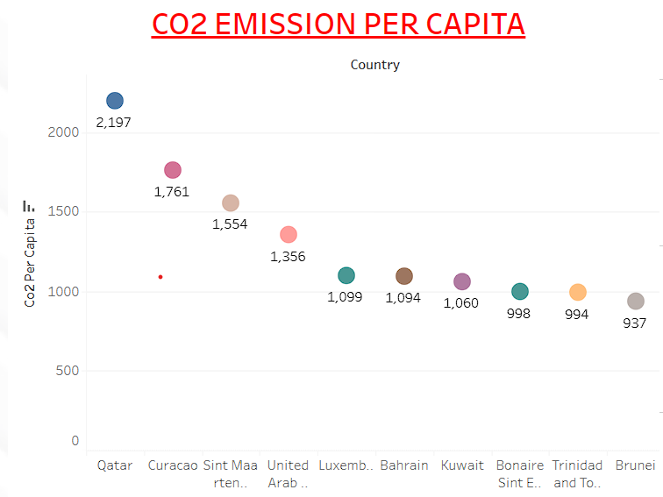

### **😊 Co2 Emission Per Capita, Co2 Emission by International Factors, Emission Rate Over Years**

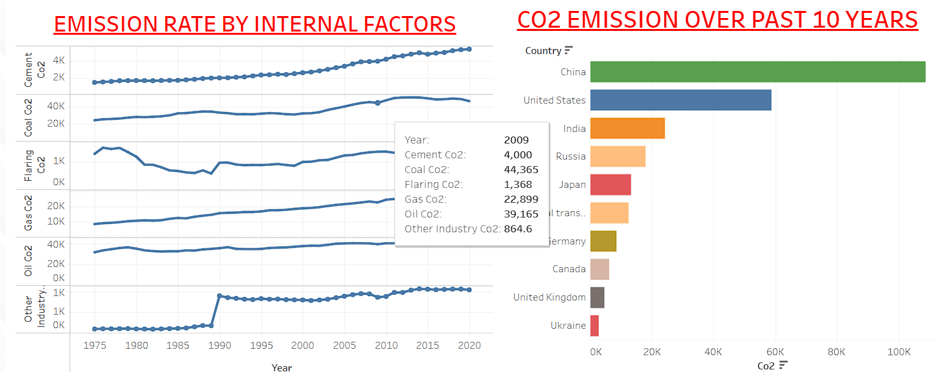

### **😊 Co2 Contribution by Different Fossil Fuels, Co2 Emission Over Past 10 Years, Change in Co2 Emission and Co2 Emission In 2020**

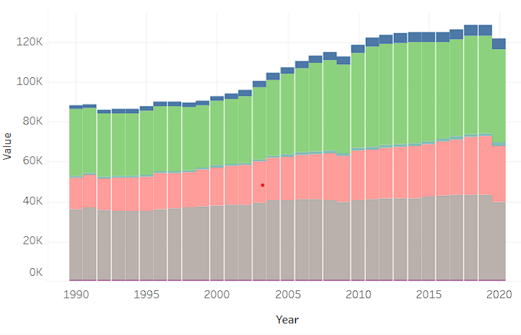

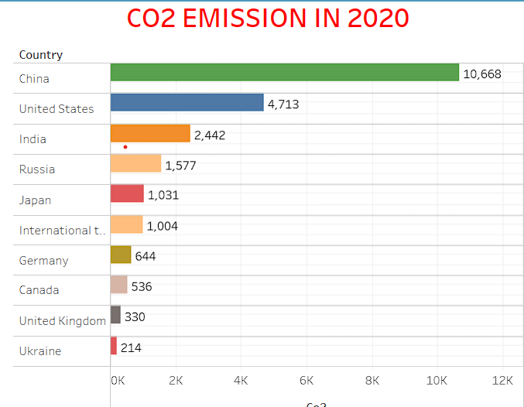

# Dashboard

A dashboard is a graphical user interface (GUI) that displays information and data in an organized, easy-to-read format. Dashboards are often used to provide real-time monitoring and analysis of data and are typically designed for a specific purpose or use case. Dashboards can be used in a variety of settings, such as business, finance, manufacturing, healthcare, and many other industries. They can be used to track key performance indicators (KPIs), monitor performance metrics, and display data in the form of charts, graphs, and tables.

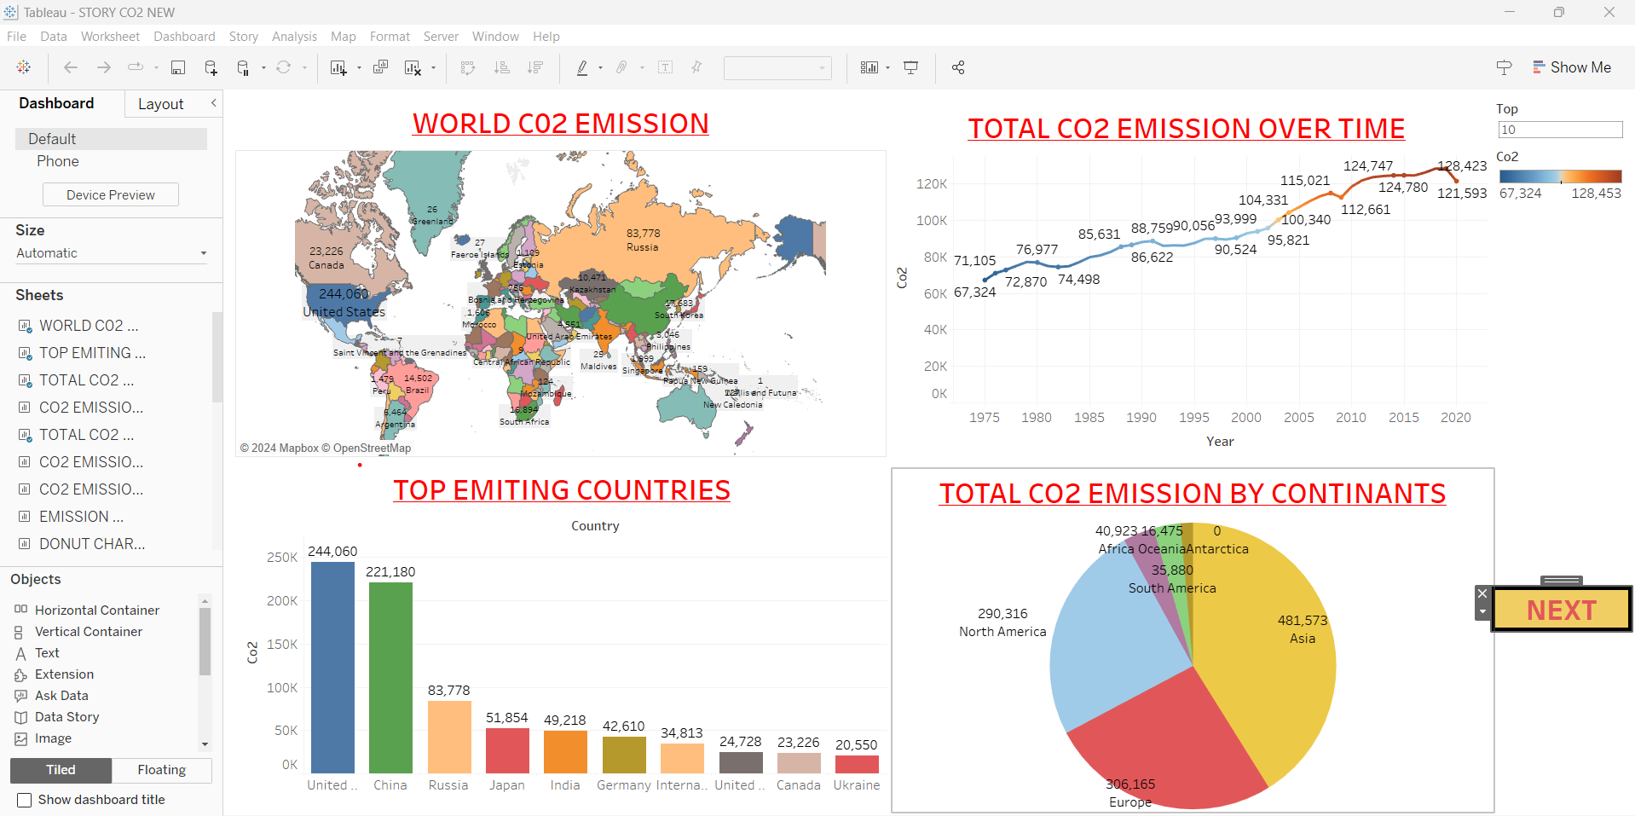

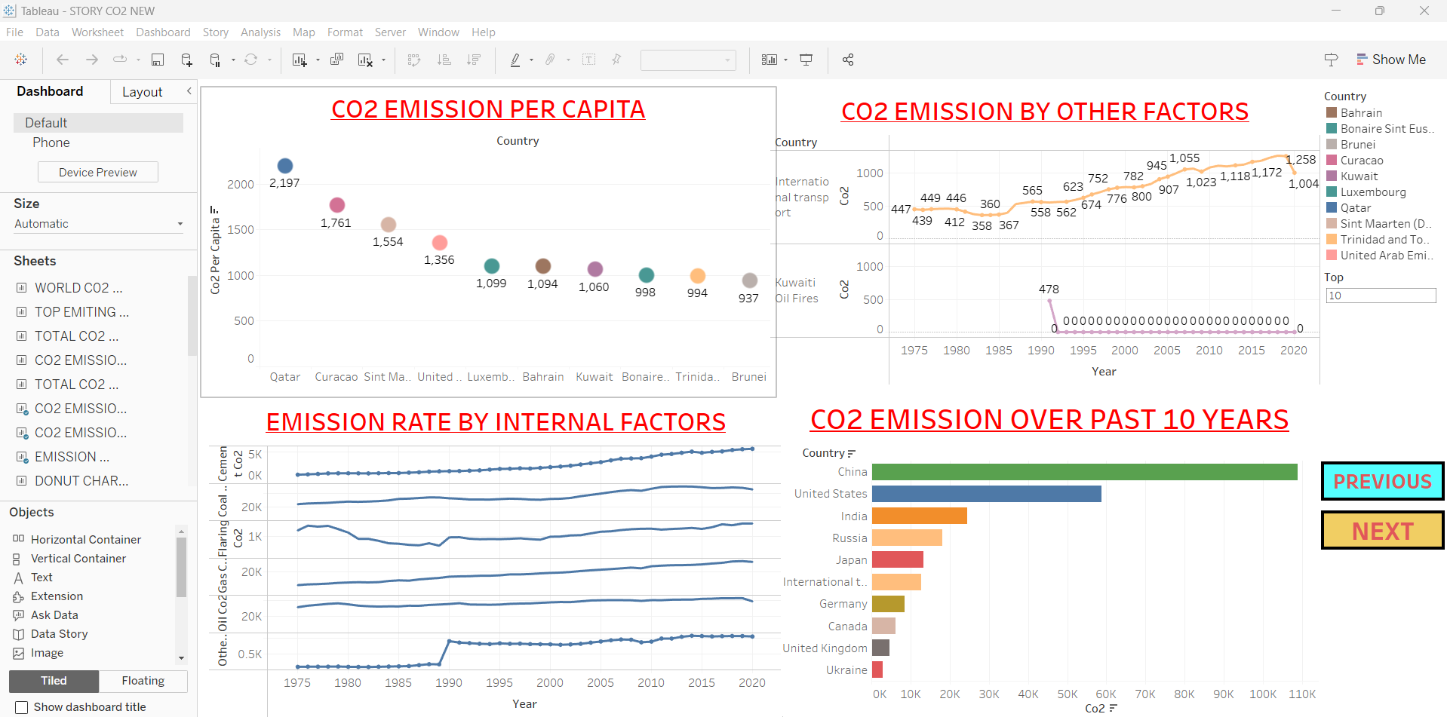

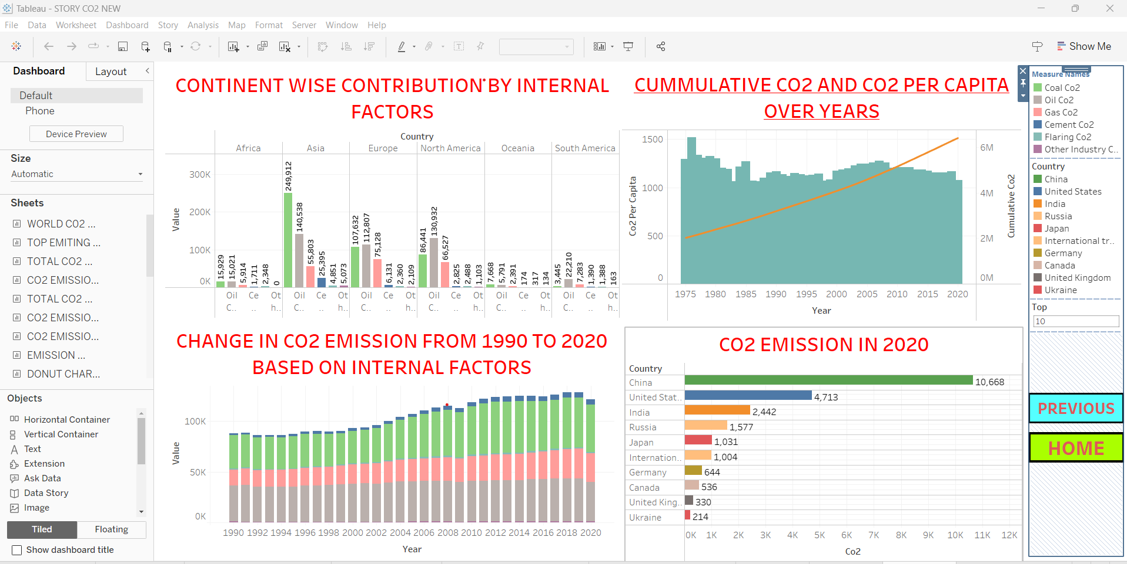

### **Story**

A data story is a way of presenting data and analysis in a narrative format, with the goal of making the information more engaging and easier to understand. A data story typically includes a clear introduction that sets the stage and explains the context for the data, a body that presents the data and analysis in a logical and systematic way, and a conclusion that summarizes the key findings and highlights their implications. Data stories can be told using a variety of mediums, such as reports, presentations, interactive visualizations, and videos.

Link :

<https://public.tableau.com/views/CO2emitionanalysisSTORY/C02EMITIONSTORY?:language=en-US&publish=yes&:sid=&:display_count=n&:origin=viz_share_link>

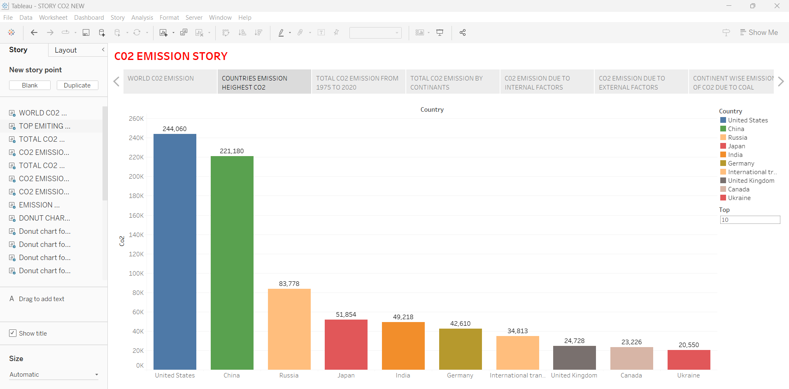

### **Publishing And Web Integration**

Publishing helps us to track and monitor key performance metrics, to communicate results and progress. help a publisher stay informed, make better decisions, and communicate their performance to others.

### **Publishing Dashboard and Reports To Tableau Public**

**Step 1:** Go to Dashboard/story, click on the share button on the top ribbon

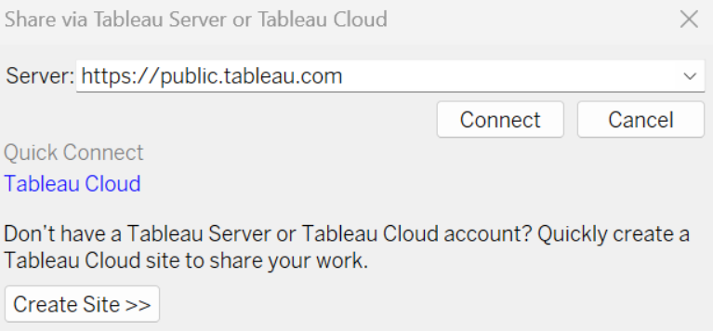

**Step 2:** Once you click on connect it will ask you for the tableau public username and password  


Once you login into your tableau public using the credentials, the particular visualization will be published into the tableau public

**Note: While publishing the visualization to the public, the respective sheet will get published when you click on the share option.**

### **Integrating In Web With Embedded Code**

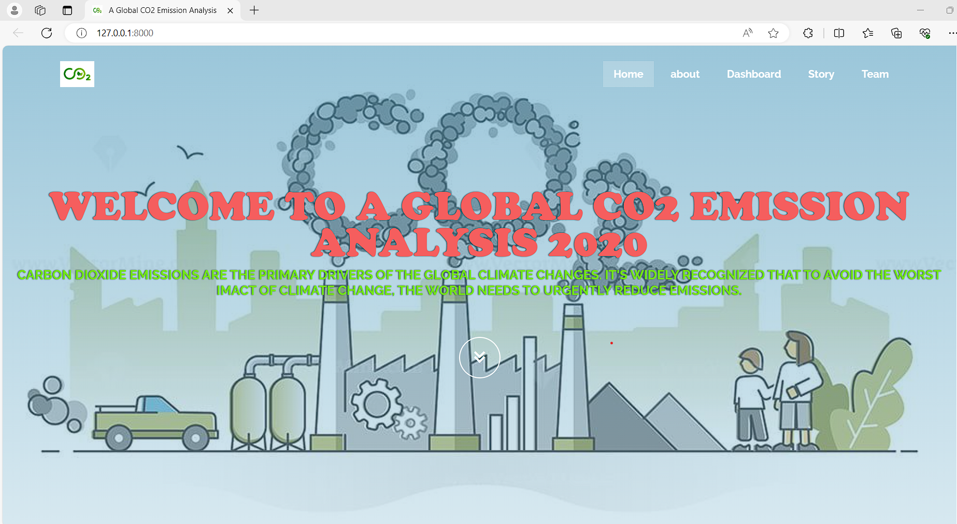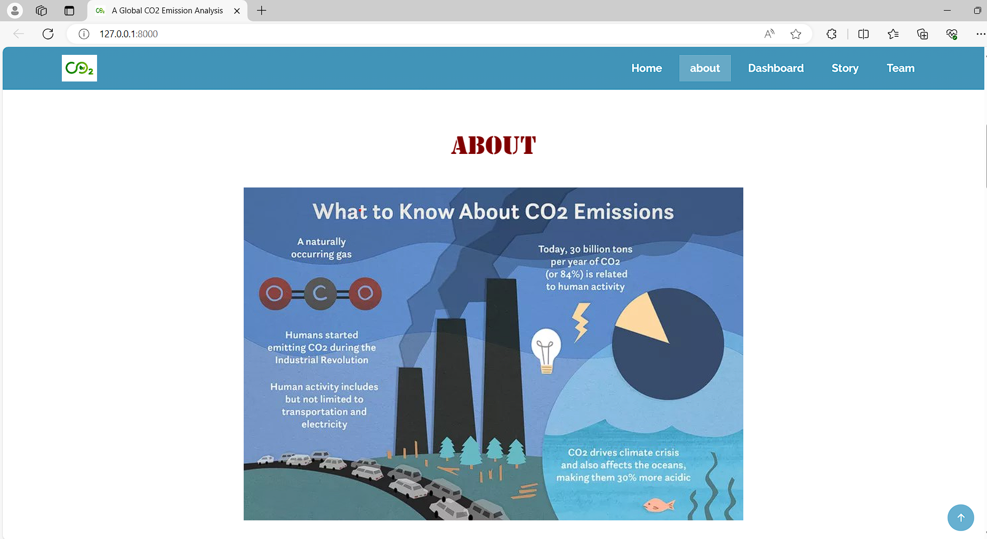

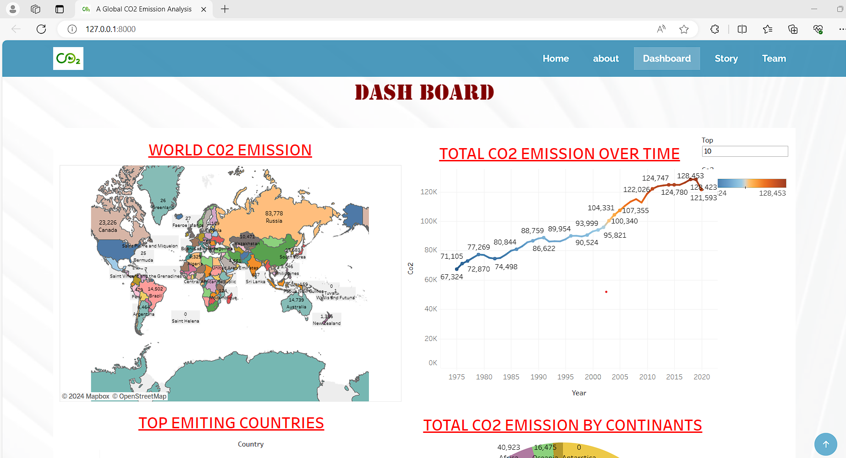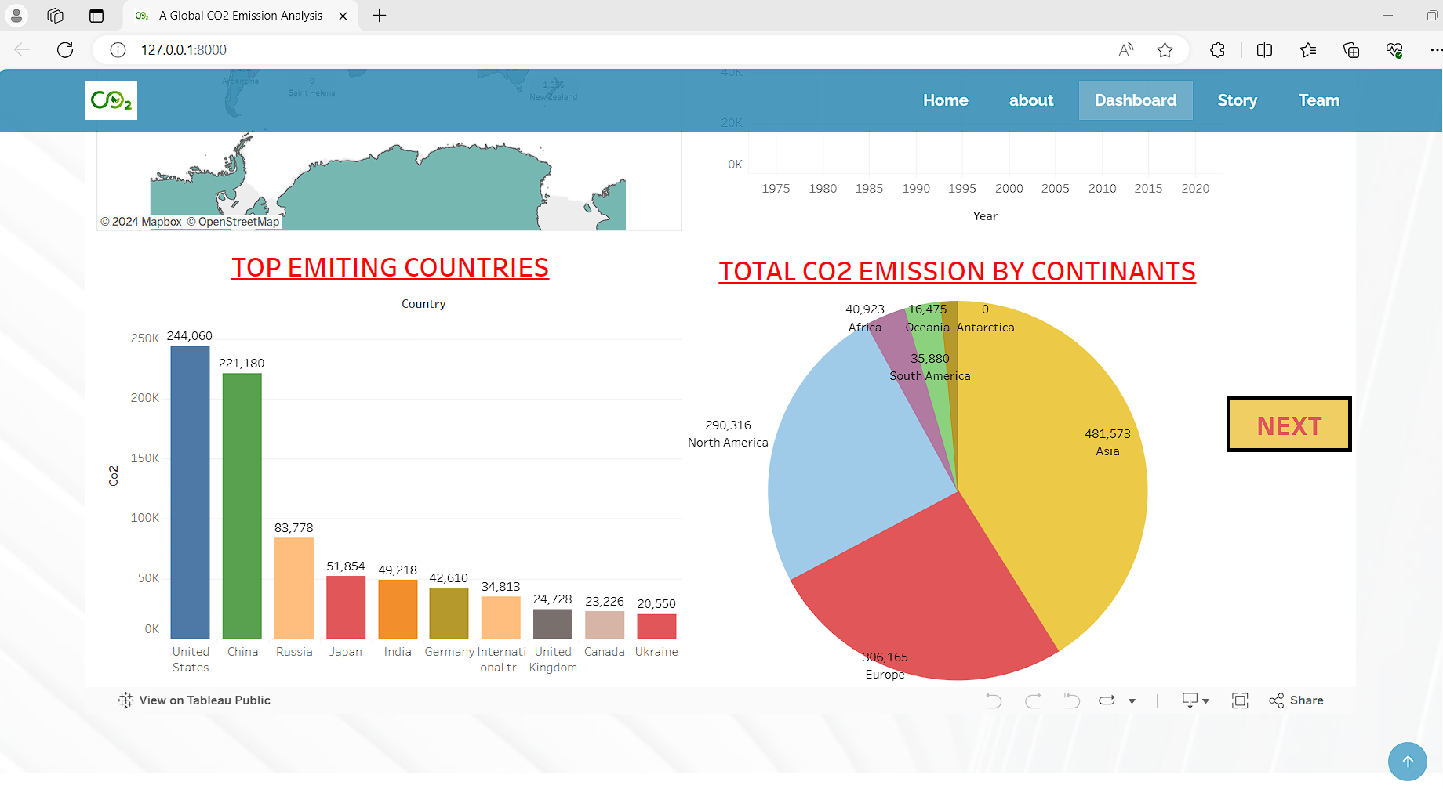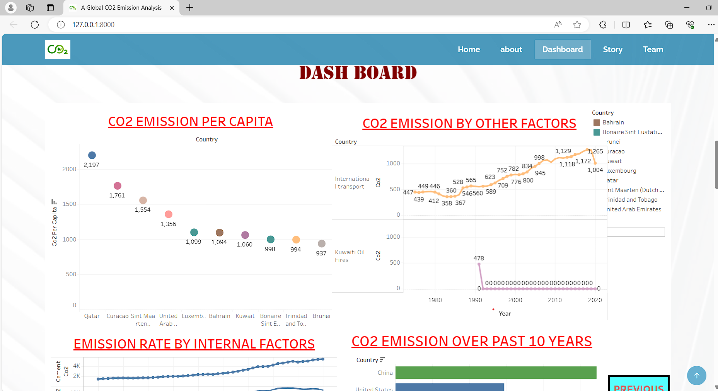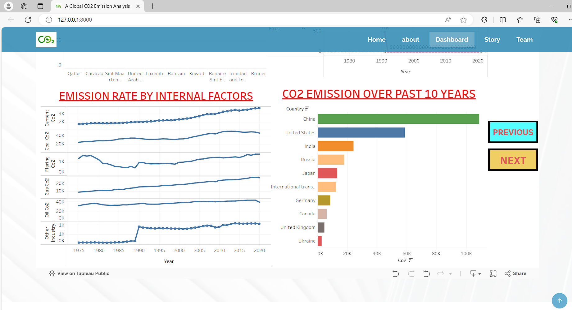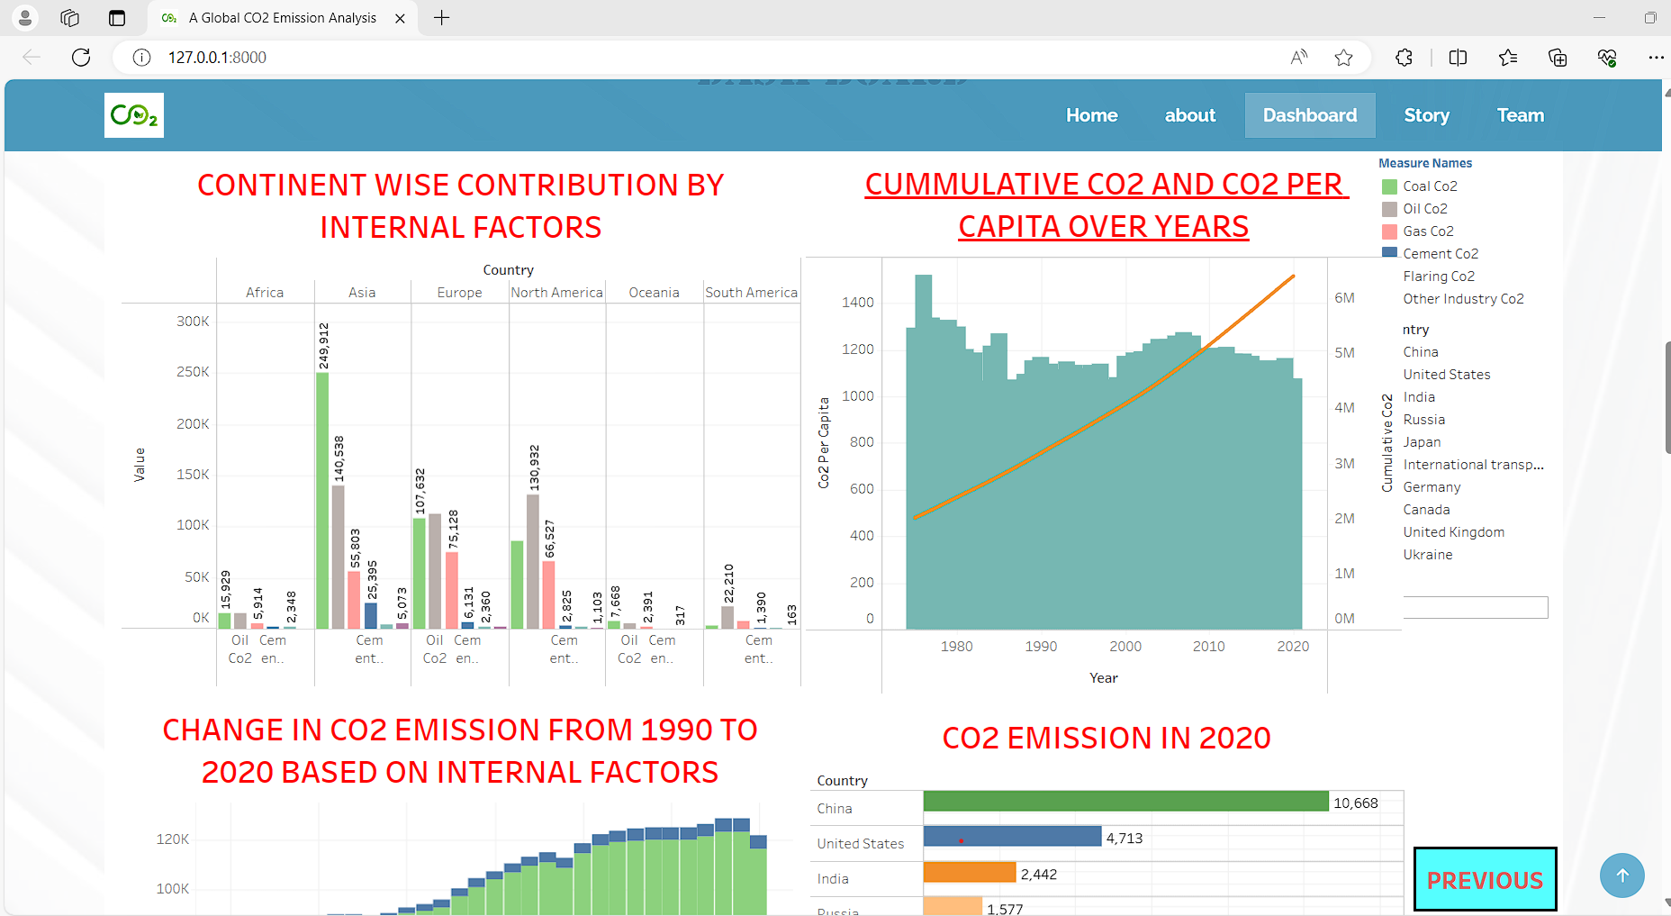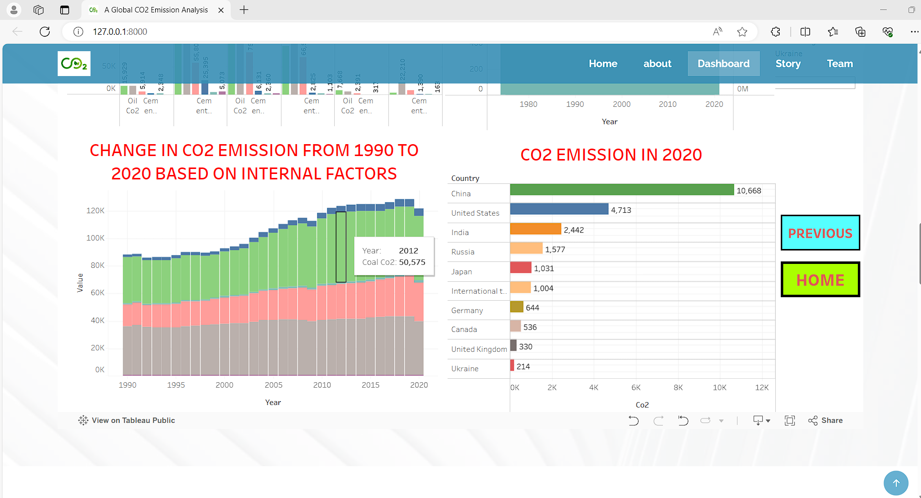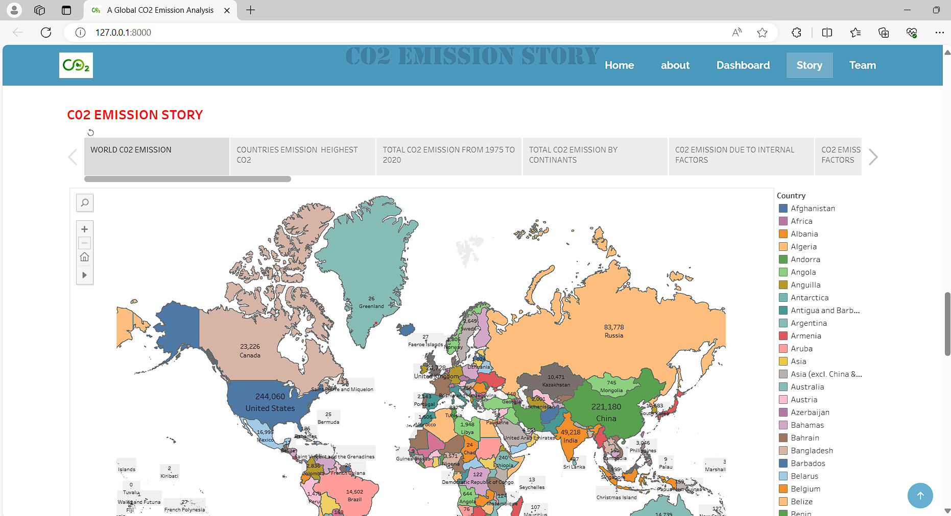

### **Conclusion**

* China is the highest Co2 Emitting country among the other countries. The
* The United States is the second highest Co2 Emitting country.
* Asia is the highest Co2 Emitting country among the other continents.
* Coal is the highest factor of Co2 Emission.
* Co2 Emission in 1975 was 67324 (in metric tons).
* Co2 Emission in 2020 was found to be 121593 (in metric tons).